  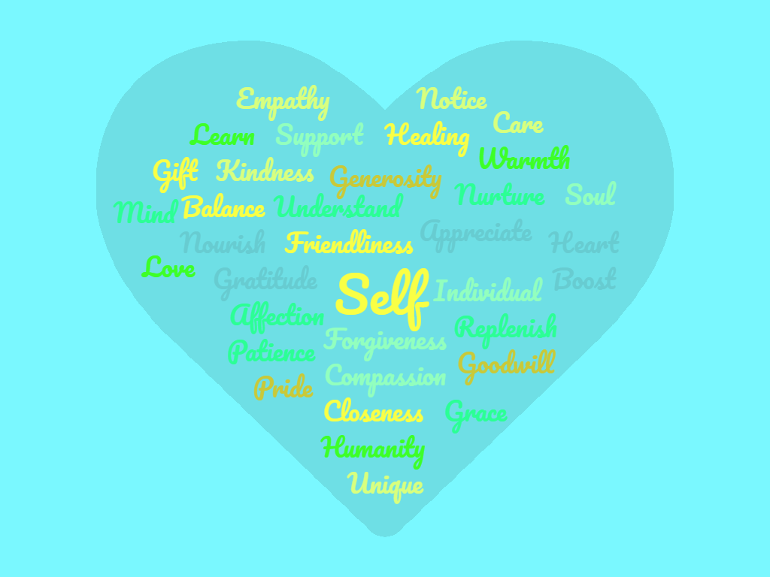
  We are proud to present this amazing 3 hour workshop:
  “Something beginning with YOU, Learning the Art of self-compassion”
  Two dates available:
  Thursday 23rd August 2018 From 10am-1pm
  VENUE: The Hub, Quarry Farm, Bodiam,
  TN32 5RA
  OR
  Saturday 18th August from 10am-1pm
  VENUE: Kings Road Studio, St leonards on Sea, Hastings
  Please contact Jo or Catherine on
  simmondscat@gmail.com or Joanna.cbtme@gmail.com
  07944428005 or 07950454247
  Cost just £35 per person!
  Are you feeling like you need to make a change but don’t know where to start?
  During this 3 hr workshop you will learn
  What is self -compassion and why is it so important?
  Learn to identify (and overcome) the unhelpful thoughts, feelings and behaviours that can get in the way
  Find out how to build self- compassion into your day to day life
  During
  www.beforethepop.co.uk
  07950 454247
  www.creativetailoredtherapy.com07944428005
  Jo Gray and Catherine Simmonds are fully qualified and experienced cognitive behavioural therapists.
  BABCP Accredited
  PG Dip CBT.

